A positively skewed distribution is one in which the tail of the distribution shifts towards the right, i.e., it has a tail on the positive direction of the curve.

The reason for this skewness is that the mass of the distribution occurs on the left side of the positively skewed distribution curve. This means that most values of the distribution occur on the left side.
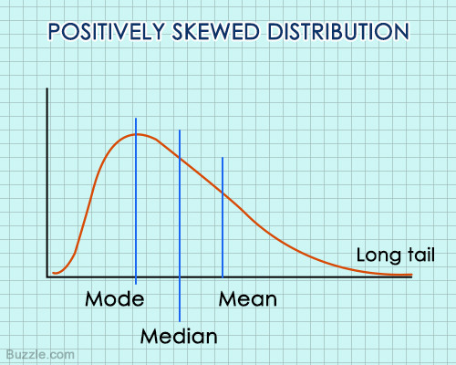

Distribution of Income
If the distribution of the household incomes of a region is studied, from values ranging between $5,000 to $250,000, most of the citizens fall in the group between $5,000 and $100,000, which forms the bulk of the distribution towards the left side of the distribution, which is the lower side. However, a couple of individuals may have a very high income, in millions. This makes the tail of extreme values (high income) extend longer towards the positive, or right side. Thus, it is a positively skewed distribution.(The values of persons having very high income shift the mean towards right side of the distribution.)

Neighborhood Housing Prices

The variation in housing prices is a positively skewed distribution. For example, if a neighborhood has 100 houses, with 99 of them having a price of $100,000, while only one sells at $1,000,000, then the frequency of houses selling at $100,000 will be maximum towards the left side of the distribution, since it is a lower value than $1,000,000. However, the single house priced at $1,000,000 will push the mean higher, and result in a long tail towards the right side, making it a positively skewed distribution.

Negatively Skewed Distribution
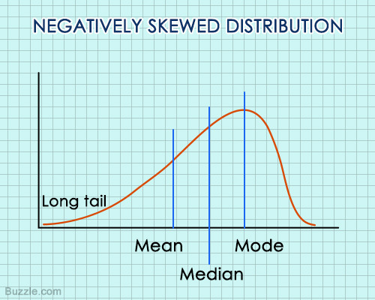
In such a distribution, the left tail is the part where the extreme values occur, and these values are smaller in magnitude. Since the mean tends to shift towards the extreme values, it is smaller in magnitude. Both the mean and median are lower than the mode, and in most of such cases, the mean will also be lesser than the median.

Retirement Age

When the retirement age of employees is compared, it is found that most retire in their mid-sixties, or older. Thus, the distribution of most people will be near the higher extreme, or the right side. However, there is an increasingly new trend in which very few people are retiring early, and that too at very young ages. This will make the tail of the distribution longer towards the left side or the lower side, and the less values (low ages) will shift the mean towards the left, making it a negatively skewed distribution.

To sum it up, a positive skew distribution is one in which there are many values of a low magnitude and a few values of extremely high magnitude, while a negative skew distribution is one in which there are many values of a high magnitude with a few values of very low magnitude.

In statistics, kurtosis describes the shape of the probability distribution curve and there are 3 main types. More specifically, kurtosis refers to the tails or the 2 ends of the curve.

Leptokurtic - a “positive” or tall and thin distribution (fatter tails).if value is more than 3."Lepto-" means "slender"
A distribution with positive excess kurtosis is called leptokurtic, or leptokurtotic. "Lepto-" means "slender". In terms of shape, a leptokurtic distribution has a more acute peak around the mean and fatter tails. Examples of leptokurtic distributions include the Student's t-distribution, Rayleigh distribution, Laplace distribution, exponential distribution, Poisson distribution and the logistic distribution. Such distributions are sometimes termed super Gaussian.

Mesokurtic - a normal distribution.if value is =3.
A distribution with zero excess kurtosis is called mesokurtic, or mesokurtotic. The most prominent example of a mesokurtic distribution is the normal distribution family, regardless of the values of its parameters.

Platykurtic - a “negative” or flat and wide distribution (thin tails).if value of kurtosis is less than 3."Platy-" means "broad"
A distribution with negative excess kurtosis is called platykurtic, or platykurtotic. "Platy-" means "broad".In terms of shape, a platykurtic distribution has a lower, wider peak around the mean and thinner tails. Examples of platykurtic distributions include the continuous or discrete uniform distributions, and the raised cosine distribution. Such distributions are sometimes termed sub-Gaussian.

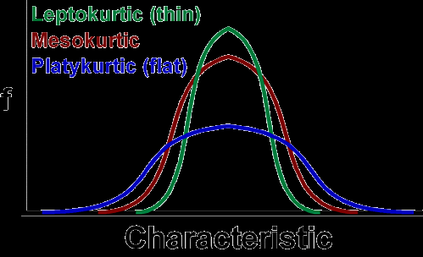
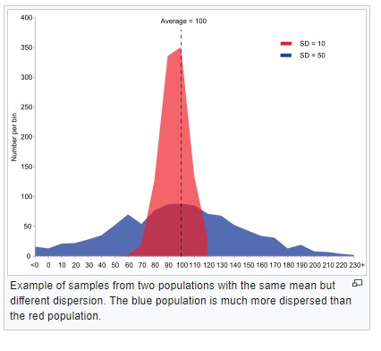
Average vs. Median
The median is very useful for describing things like salaries, where large figures can throw off the mean (the average). The median salary in the U.S. as of 2012 was $51,017. If an average was used, those American billionaires could skew that figure upwards.

Let’s say you wanted to work for a small law firm that paid an average salary of over $73,000 to its 11 employees. You might think there’s a good chance you’ll land a great paying job. But take a closer look at how the average is calculated for those eleven employees:

Employee Salary
Samuel $28,000
Candice $17,400
Thomas $22,000
Ted $300,000
Carly $300,000
Shawanna $20,500
Chan $18,500
Janine $27,000
Barbara $21,000
Anna $29,000
Jim $20,000
Average (Mean) =
($28,000 + $17,400 + $22,000 + $300,000 + $300,000 + $20,500 + $18,500 + $27,000 + $21,000 + $29,000 + $20,000) / 11 = $73,000

The two partners in the firm—Ted and Carly, have increased the average way beyond most of the salaries paid in the firm.

See how the “average” can be misleading?

A better way to describe income is to figure out the median — or the middle wage. If you took that same list of incomes and found the median, you would get a more realistic representation of income. The median is the middle number, so if you placed all of the incomes in a list (from smallest to largest) you would get:

$17,400, $18,500, $20,000, $20,500 $21,000, $22,000, $27,000, $28,000, $29,000, $300,000, $300,000
It’s a more accurate representation of what people are actually being paid.

measures of Central Tendency
A measure of central tendency is a single value that attempts to describe a set of data by identifying the central position within that set of data. As such, measures of central tendency are sometimes called measures of central location.
The mean, median and mode are all valid measures of central tendency, but under different conditions, some measures of central tendency become more appropriate to use than others.

Mean
The mean (or average) is the most popular and well known measure of central tendency. It can be used with both discrete and continuous data, although its use is most often with continuous data (see our Types of Variable guide for data types).
we have n values in a data set and they have values x1, x2, ..., xn, the sample mean, usually denoted by (pronounced x bar), is:
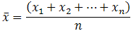

An important property of the mean is that it includes every value in your data set as part of the calculation. In addition, the mean is the only measure of central tendency where the sum of the deviations of each value from the mean is always zero.

Measures of dispersion
The range is one of the easiest measures of dispersion to calculate. It is just the difference between the maximum and minimum values in your data set. Using my example from yesterday, the maximum and minimum transactions were $250.71 and $43.24, respectively. Therefore, the range, $207.47, gives us a quick indication that the transaction amounts are pretty spread out.

Though the range is helpful for knowing the “width” of your data, you still don’t have a sense as to where most values fall – are they close together or very spread out? That’s what the standard deviation and its related metric, the variance, tell you¹. They measure how far your data points fall from the mean.

Measures of central tendency, Mean, Median, Mode, etc., indicate the central position of a series. They indicate the general magnitude of the data but fail to reveal all the peculiarities and characteristics of theseries. In other words, they fail to reveal the degree of the spread out or the extent of the variability inindividual items of the distribution. This can be explained by certain other measures, known as ‘Measures ofDispersion’ or Variation.
We can understand variation with the help of the following example :

----------------------------------------------

Series 1 Series 11 Series III

---------------------------------------------
10 2 10
10 8 12
10 20 8

---------------------------------------------
∑X = 30 30 30

----------------------------------------------

Questions

Problem: Below is the table showing the values of the results for two companies A, and B.
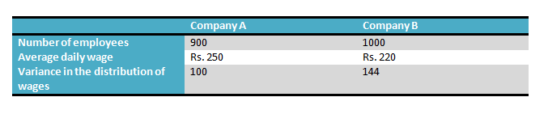
- Which of the company has a larger wage bill?

A student has gotten the following grades on his tests: 87, 95, 76, and 88. He wants an 85 or better overall. What is the minimum grade he must get on the last test in order to achieve that average?
6. Find the mean of the following distribution.
(a) The age of 20 boys in a locality is given below.
Age in Years | 12 | 10 | 15 | 14 | 8
Number of Boys | 5 | 3 | 2 | 6 | 4
(b) Marks obtained by 40 students in an exam are given below.
Marks | 25 | 30 | 15 | 20 | 24
Number of Students | 8 | 12 | 10 | 6 | 4
##
If we want an average distance to the mean, why can't we just add up all the differences to the mean and take the average?
The negative and positive values will cancel each other out. Correct Answer
##
In 2000 the mean weight of 10 year olds was found to be and the standard deviation was 3.5.
In 2010 the mean weight of 10 year olds was found to be and the standard deviation was 2.1.
Which of these statements is a fair comparison?
In 2000, the weight of 10 year olds was less consistent than in 2010.
In 2010, 10 year olds weighed less on average than in 2000.
In 2010, the weight of 10 year olds was less consistent than in 2000.

##Q
The means of two samples of size 50 and 100 respectively are 54·1
and 50·3 and the standard deviations are 8 and 7. Obtain the mean and standard
deviation of the sample of size 150 obtained by combining the two samples.

##Q
The average salary of male employees in a firm was Rs.520
And that of females was Rs.420. The mean salary of all the employees was Rs.500.
Find the percentage of male and female employees.

Skewness is a measure of symmetry, or more precisely, the lack of symmetry. ... Kurtosis is a measure of whether the data are heavy-tailed or light-tailed relative to a normal distribution. These measures are mutually exclusive i.e. the presence of skewness implies absence of kurtosis and vice-versa.

